HAPPY FEET, WOMBO COMBO
BRAWL EDITION
A Brawler’s guide to getting asses whooped
by Secret Wizard {Discussion}
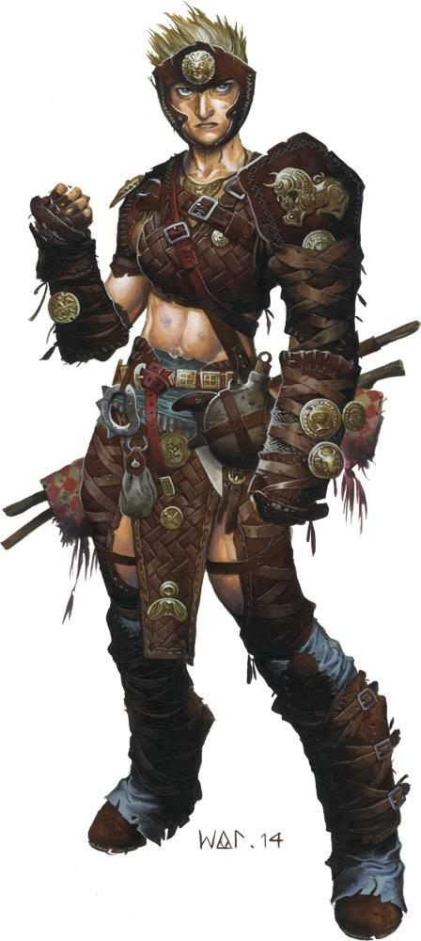

GUIDE NAVIGATION
- Color Coding.
How to read this guide.
- Class Analysis
Understanding the class.
- Skills
- Race Selection
General guidelines.
- Build considerations
Finesse, Dirty Fighting, Maneuvers, Styles.
- Archetypes & Attributes
- Equipment
- Traits
- Martial Flexibility
- Multiclass Options
- Sample builds

[CAVEAT LECTOR: If you are not interested in making the most optimized build, then by all means, disregard my assessments. Making the build you find fun is probably a better use of your time.]

